Event/Activity (brief description): |  |  |  |  |  |  |  |  | Date:
Event Co-ordinator: |  |  | Numbers attending: |  |  | Adults |  |  |  | Girls / Young Women |  | General Public
Deputy Event Co-ordinator:

Consent for Event/Activity forms completed: (circle)  Yes No N/A |  |  | Venue:  Risk assessment checked:  Yes No N/A ) |  |  | Instructor qualifications checked  Yes No N/A  (if applicable) :
Home Contact : |  |  | Home contact form signed:  Yes No |  |  | Safe space training for all adults checked :
Benefits of the Event

Girls

Adults

Hazards  What could cause harm or damage? | Who or what is at risk of being affected and how? | What are you already doing?  How have you reduced the risk already? |  | Likelihood of Risk Occurring  (L / M / H) | Severity of Risk  (L / M / H) |  | Are further controls necessary?  What else needs to happen to reduce the risk to an acceptable level? |  |  |  |  |  | Action by: name  & date

Hazards  What could cause harm or damage? | Who or what is at risk and how? | Action Already Taken  How have you reduced the risk already? |  | Likelihood of Risk Occurring  (L / M / H) | Risk level  (L / M / H) | Are further controls necessary?  What needs to happen to reduce the risk to an acceptable level? |  | Action by: name  & date
Decision: once all the actions are carried out, can you manage the risk and go ahead with this event or activity? (i.e. have a degree of challenge and risk whilst keeping girls safe) |  |  |  |  |  | Yes / No
Please explain your ‘Decision’ response
Risk Assessment Completed By: insert name and role |  |  |  |  |  | Date completed:
Has the Risk Assessment been shared with the leadership team? |  |  |  |  |  | Yes / No
Risk Assessment due for Review: insert date (no more than 12 months time)

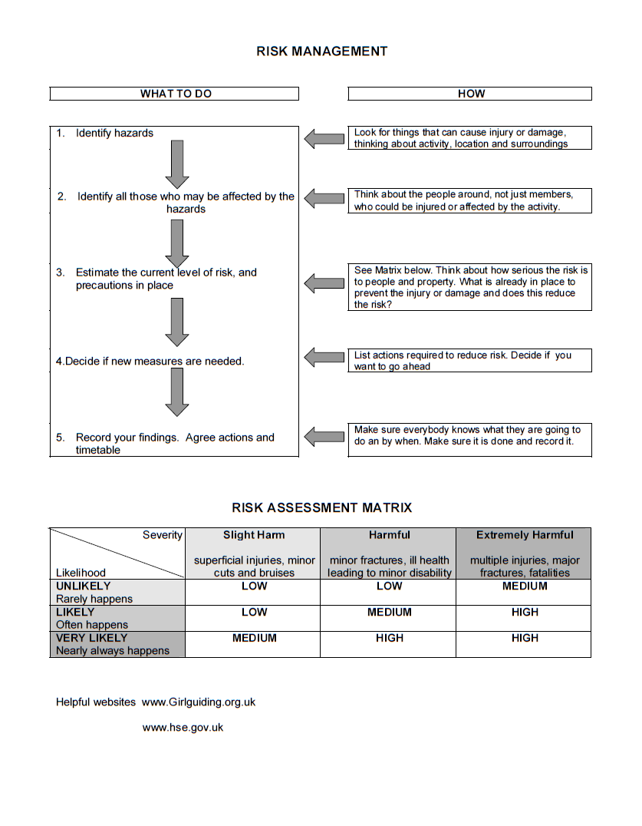


Categories of Risk to consider

This is not an exhaustive list and you may need to add others for a particular activity/event or have less for a smaller event.

Category | Detail | Considered
Finance | Event/activity/Unit budget
 | Contingency/emergency funds
 | Underwriting any over spend
 | Dealing with surplus monies
 | Fundraising
 | Grants
 | Refunds for events – wording needs to be carefully written
 | Other – Please add your own boxes and titles
Reputation | Guide wear - e.g. are we in a public place?
 | Behaviour - are we encroaching on other people’s leisure?
 | Public perception -are we behaving as Guides should? Is it a good PR exercise
 | Information Technology –is there a security risk if collecting data for events/data protection breach ? Where is the data stored? GDPR regulations?
 | Administration and organisation of event - are the leaders. Parents, supporters happy with the organisation?
 | Safety of members do we need to put further safety procedures in place to ensure everyone is safe?
 | Staff are they fully briefed on the event and their role
 | Other – please add your own boxes and titles
Activities | Check Manual for prohibited activities are special requirements needed?
 | Suitable for age group
 | Adult to child ratios – check in Guiding Manual
 | Qualified Instructors – information about qualifications should be requested from all external providers
 | Suitable clothing/footwear – would wearing inappropriate clothing cause a risk to health and well being?
 | Weather/time of year
 | Suitable venue/space - have we asked for their Risk assessment?
 | Appropriate equipment - if hired have we asked for the providers risk assessments and insurances ?
 | Risk Assessment of instructor/provider of activities
 | Other – please add your own boxes and titles
People | Leader Qualifications - have they been checked if needed for a sleepover or overnight event
 | Unit Helpers
 | Parent Helpers
 | Girl members - provide wrist bands or security badges so they know how to contact leaders if lost or detached from group
 | Members with disabilities – how would you evacuate?
 | Male Unit Helpers/Helpers - are they dbs checked? Do they have suitable toilet facilities etc
 | Visitors are visitors allowed? Vetting in advance. Membership numbers to be provided if in organisation and DBS required.
 | Staff members - name badges?
 | D of E Volunteers
 | Non-member children can they be left at home with another family member ? or is there a crèche?
 | Member children non section age group are there enough adults
 | Event numbers - if large scale , do we have enough toilets ,showers etc?
 | Adult/child ratios
 | Home Contact/s
 | Refreshments / water points /food
Equipment | Any items used for an activity or event that is the responsibility of the organising team or participants
 | Electrical – PAT tested?
 | Suitability for age group/ability of participants
 | Risk Assessment of instructor /provider of activities to be checked
 | Other – please add your own boxes and titles
Venue | Has somebody completed a site visit?
See and incorporate the venues own risk assessment
Building, Site or other area being used

 | Disability access how can we make the event accessible?
 | Fire procedures including fire/evacuation drills - should be explained at start of event if indoors
 | Fire extinguishers –check the location and type
 | Fire Alarm
 | Where is the muster point
 | Temperature of water
 | Temperature of exposed radiators
 | Emergency lighting
 | Security Lighting
 | Isolation points for services eg electricity, gas, water etc
 | Furniture is it safe?
 | Public access how do you deal with public ?
 | Toilets and wash basins – cleanliness, supplies of toilet paper and soap
 | Kitchen area – safe storage, appropriate equipment, ovens and hobs, fridges, freezers, microwaves, urns. Are we allowed to use ?
 | Indoor Space clearing up and leaving as found
 | Outdoor Space - clearing up , broken glass , litter leave as found
 | Emergency and communication procedures in case of unforeseen events eg terrorist attack, protest march
 | Outdoor event depends on the venue but may need extra thoughts
 | Other – please add your own boxes and titles
Miscellaneous | Drop Off and collection of participants – do we have enough people to organise coaches /cars ?
 | Travel arrangements
 | First Aid provision who , where?
 | Transport public transport issues
 | Region Mobile phone –put numbers in phones before arriving at event
 | Set up What’s app site for emergency communication in case of terrorism
 | Death of a Participant -misadventure or natural causes
Other– | please add your own boxes and titles

