Council membership
Application pack 2026

Contents
Welcome 2
1. What does Girlguiding’s Council do? 3
2. What would my responsibilities be as a Council member? 4
3. What skills and knowledge do I need? 5
4. How to apply 6


Welcome
Being a Council member is a fantastic opportunity for you to shape Girlguiding’s future. Thanks so much for your interest in joining the team.
Our Council is a really crucial part of Girlguiding. It’s where members (aged 14+) from our countries and regions can come together and talk about guiding. Our Council ensures our members’ voices are heard and are at the heart of our organisation.
Girlguiding thrives on the collective strength of passionate and engaged individuals, and as a Council member, you have the opportunity to actively engage in the vibrant discussions that shape the direction of Girlguiding, and stay briefed on our initiatives.
Please do spend a few minutes looking through this pack to find out more about how you can be part of it. I very much hope you’ll feel inspired to apply.
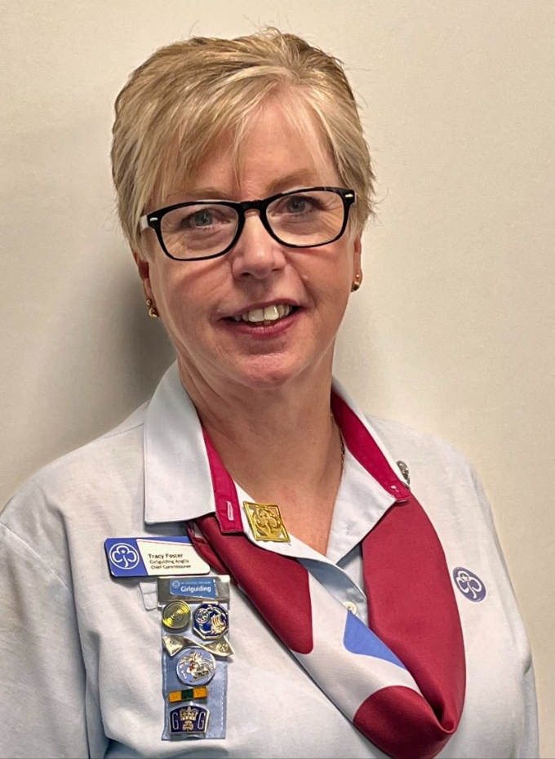
I look forward to meeting our new Council members soon, and working with you to give our Rainbows, Brownies, Guides and Rangers a brilliant guiding experience.
With very best wishes,
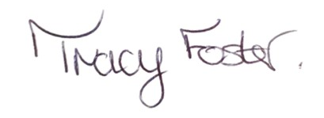

Tracy Foster
Chief Guide

What does Girlguiding’s Council do?
The role of Council is to provide a forum for its members from all countries and regions to engage with Girlguiding at a national level.
Our Council meets once a year for an annual general meeting (AGM) – usually June. Here members have the chance to review and discuss the annual report of the board of trustees , and our annual financial accounts. We also sometimes ask members to meet and give their opinions on other important issues that come up throughout the year.
The Council formally appoints our president, vice-presidents and patrons too, plus agrees the process for choosing our chief guide. Members also sign off any changes to the documents that set out how Girlguiding should work (our Royal Charter and Bye-laws).
Council plays an important role in being engaged at and between meetings on matters that affect the organisation. Sometimes, this means helping make big decisions, like changing the rules to create a separate Chair of the Board position. Other times, it’s about sharing information, gathering opinions, and getting input—like talking to members about our environmental strategy.
Our Council is made up of different kinds of members so it represents everyone at Girlguiding. Members from our countries and regions (known as ‘elected members’) work alongside members who are on our Council because of their role (‘ex officio members’). These include our chief guide, deputy chief guide and chief commissioners.
Each of Girlguiding’s countries and regions has four places on our Council for elected members. Council members serve for three years to begin with. They can then stay on the Council for another three years if their country/region wants them to. Council members must be aged 14 or over when they start their term.

What would my responsibilities be as a Council member?
In this exciting and varied role, you’ll:
- Take an active part in debates about Girlguiding’s future and priorities
- Act as a champion for positive change and innovation in the country/region you represent
- Act as a role model for Girlguiding’s values
- Take part in the process of choosing our chief guide
- Attend Council meetings
- Participate in discussions and voting on issues



What skills and knowledge do I need?
Our Council members should be:
- Able to show their understanding of how Girlguiding is relevant to the lives of girls and young women today
- Able to assist with facilitation of discussions and report accurately on Council discussions
- Interested in, and enthusiastic for, shaping and advising on Girlguiding’s future
- Able (or ready to learn) to use and contribute using communication tools like Microsoft Teams, Zoom, SurveyMonkey and blogging
- Committed to upholding Girlguiding’s values and contributing to a culture of respect, integrity and kindness.

Other useful skills and knowledge
Ideally, Council members would also have:
- Knowledge of or interest in trends/issues relevant to Girlguiding affecting the UK and world
- A keen interest in, and commitment to, Girlguiding, and possibly in serving on the trustee board and/or committees in the future

How to apply

To become an elected Council member, you should apply to your country or region directly, when you see a vacancy advertised. To do this:

Fill in the application form that comes with this pack, and send it to the email address given by the deadline. Remember to let us know what skills and knowledge you have from the lists in section 2.

Ask for two nominations for the role from commissioners or Council members from your country/region. If you’re under 18 you can ask your unit leader to nominate you. You could also ask their advice on who else to approach for a nomination.

Complete the first part of the nomination form, also included with this pack. Send it with a copy of this pack to the two people nominating you. Ask them to fill in the nomination form and send it to the email address given by the deadline.

Once the deadline for applications has passed, a country/region panel will assess all applications. The panel will include the chief commissioner and at least two other country/region level volunteers. They’ll decide who to offer the Council member role to.
We’ll only advertise vacancies in a country/region when there’s an opening. There won’t be vacancies in every country and region every year.
We appreciate and value the different experiences and skills that all kinds of members can bring to our Council. We welcome applications from people of all backgrounds. We’re particularly interested in hearing from people from communities that are underrepresented on our Council. This includes people of colour, disabled people, LGBT+ people, people from minority faith groups, and those facing socio-economic disadvantage.
Please note that if members aged 16 and under are unable to travel to a meeting with another member of the country or region delegation, Girlguiding will pay reasonable travel expenses for another adult to accompany them.

Any questions
If you have any queries about anything in this pack, please contact us at governance@girlguiding.org.uk.

