
Volunteer role information
Deputy chief commissioner
Are you a motivational leader, passionate about empowering girls and young women and keen to use those skills to help shape our region? We’re looking for a deputy chief commissioner to join the new chief commissioner team.
This is a fantastic opportunity to work with trustees, senior volunteers and staff to shape our strategic direction and represent over 50,000 members in Girlguiding London and South East England regionally and nationally. You’ll help create an inclusive, empowering culture that supports volunteers to give girls and young women opportunities to grow in confidence and fulfil their potential.
Could you be our new deputy chief commissioner?
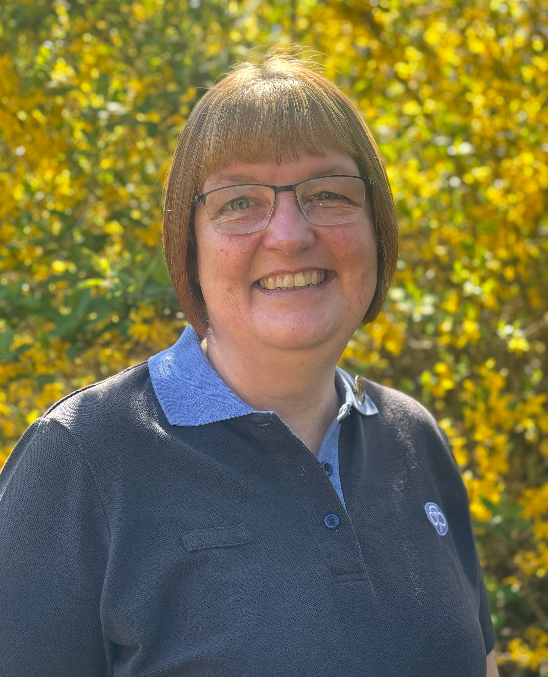
Thank you for your interest in this exciting role.
As deputy chief commissioner, you’ll play a key role in shaping our region’s future. Working closely with me and the wider leadership team, you’ll help deliver our strategy, guide our direction and ensure Girlguiding London and South East England continues to grow, adapt and thrive sustainably in a changing world.
I’m looking for an energetic, strategic and collaborative leader who listens well, supports others and is passionate about Girlguiding’s mission and values.
There will be challenges along the way, but this role offers the chance to make a real difference. You’ll develop your skills, have rewarding experiences and take on exciting opportunities.
Could this be your next Girlguiding adventure? If you think it could be, I’d love to hear from you!
Best wishes,


Chief commissioner designate
Girlguiding London and South East England
About the role
- You must be aged 18+ and an active member of Girlguiding London and South East England
- Serve as a trustee of Girlguiding London and South East England
- Support the chief commissioner, trustees, region manager and senior staff in leading the region
- Represent the region locally and nationally
- Attend and contribute to meetings, events, and working groups, helping to shape key discussions and decisions
- Work collaboratively with volunteers, advisers, staff and young members to develop and deliver projects, events and activities, promoting opportunities across the region
What we're looking for
- A committed and enthusiastic adult volunteer who is passionate about Girlguiding's mission and values
- This is a senior role which can be flexible to sit alongside work and other commitments, but you must be able to commit the necessary time to it, managing your time and prioritising tasks
- Guiding experience at district level or above, or organisational lead role in another organisation
- A confident communicator who can share ideas clearly and listen to a range of perspectives, and the confidence to manage difficult conversations
- An individual ready to take on the responsibility and accountability of being a trustee
- Experience of leading a team and chairing meetings
- A willingness to travel within the region (and on occasion further afield) to meetings and events
- Good networking skills

What we can offer you
Taking on the role of deputy chief commissioner is a significant commitment, but you will be fully supported so that you are able to make the most of this amazing opportunity.
As the deputy chief commissioner, you will benefit from:
- A thorough induction to your role
- Ongoing training and development, including guidance on governance and your responsibilities as a trustee
- Support throughout your term, with help and advice available from the chief commissioner, other chief commissioner team members, region manager, other trustees, and a network of other deputy chief commissioners
- A welcoming and collaborative environment, where your contribution is valued and you can learn from others’ experience
- Opportunities to develop skills in leadership, communication and strategic thinking
- The opportunity to make a meaningful impact by shaping the future of Girlguiding London and South East England and improving experiences for young members and volunteers

This role is offered as a 5-year term, aligning with the chief commissioner’s term of office. Reasonable expenses will be reimbursed in line with Girlguiding’s expenses policy.
To support you in your role, and ensure the safety of all members, you will be required to hold (or be willing to compete) A Safe Space Level 4.
Recruitment information:
We’re keen to hear from volunteers of all backgrounds, ages, ethnicities/ethnic groups, sexual orientations, gender identities, socio-economic backgrounds, and of all faiths and none. We’re flexible, and volunteering can be arranged to fit around a busy lifestyle. Girlguiding is committed to making reasonable adjustments to support all volunteers to access the same opportunities and experiences. Please note this is a volunteer role and does not form part of any contract of employment.
How to apply:
If you’re ready to take the next step in your Girlguiding journey and help shape the future of Girlguiding London and South East England, we’d love to hear from you.
Please complete the application form below and email it to: recruitment@girlguidinglaser.org.uk
For more information, contact Dawn Archer, chief commissioner designate: dawna@girlguidinglaser.org.uk.
Application deadline:
Midnight on Thursday 9 July. Applications will be shortlisted and candidates invited to interview.

Application form – deputy chief commissioner
Name:
Membership number:
Email:
Phone
Current Girlguiding roles:
Previous Girlguiding roles or volunteer experience:
Please name two referees who will support your application:  - One guiding reference from district commissioner level or higher, or a lead volunteer/adviser  - One non-guiding reference who is able to comment on your ability to communicate and engage with others effectively  These referees must be aged 18 or over and must not be related to you. | Referee 1:
 | Referee 2:
What experience and skills would you bring to this role? (max 500 words)
Explain why you would like this opportunity with Girlguiding London and South East England? (max 500 words)

