

**Membership Trustee Application Pack** 2025

**Contents**

|  |  |
| --- | --- |
| Welcome  About Us  About the board of trustees  Responsibilities of trustees  Skills needed  Annual meeting schedule  How to apply  Application form | Page 2  Page 3  Page 4  Page 5  Page 7  Page 8  Page 8  Page 9 |

**Welcome**

Thank you for your interest in becoming a trustee with Girlguiding London and South East England. As a member of Girlguiding, you will already know how fabulous our movement is and the amazing contribution we make to the lives of girls and young women across the region. In addition to our membership of over 42,000 young members and 11,000 volunteers, we employ 12 staff. Our turnover is £1,148,164.

We are totally committed to ensuring the personal development of girls and young women through our challenging and exciting programmes. Our trustee board provides strategic leadership and direction to take Girlguiding London and South East England forward. The role of a trustee offers varied and challenging opportunities for people who want to help shape Girlguiding London and South East England’s future.

We are now seeking to appoint 2-3 new membership trustees including at least one aged between 18 and 30. In addition to this we will be particularly looking to recruit people who have knowledge/skills in some of the following areas:

* IT
* Marketing, innovation & creative
* Fundraising, income generation
* Social media & digital
* Education policy & practice
* Public policy development

This pack contains further information about our structure, the role and person specification for the trustee together with an application form and details of how to apply.

I hope that after reading this pack you will feel motivated and encouraged to apply for the role. If you would like to discuss the role before you decide, then please get in touch at <trustee@girlguidinglaser.org.uk> to arrange a mutually convenient time to have an informal chat.

We very much look forward to hearing from you.   
  
Macintosh HD:Users:katiesturgess:Downloads:Amanda signature.png  
  
Amanda Teasel

**Chief Commissioner**

**Girlguiding London and South East England**

**About us**

Girlguiding London and South East England region is divided into 17 counties covering Greater London, Surrey, Sussex and Kent.

We are the leading charity for girls and young women with over 42,000 Rainbows, Brownies, Guides, Rangers and over 11,000 volunteers.

For more information visit [www.girlguidinglaser.org.uk](http://www.girlguidinglaser.org.uk).

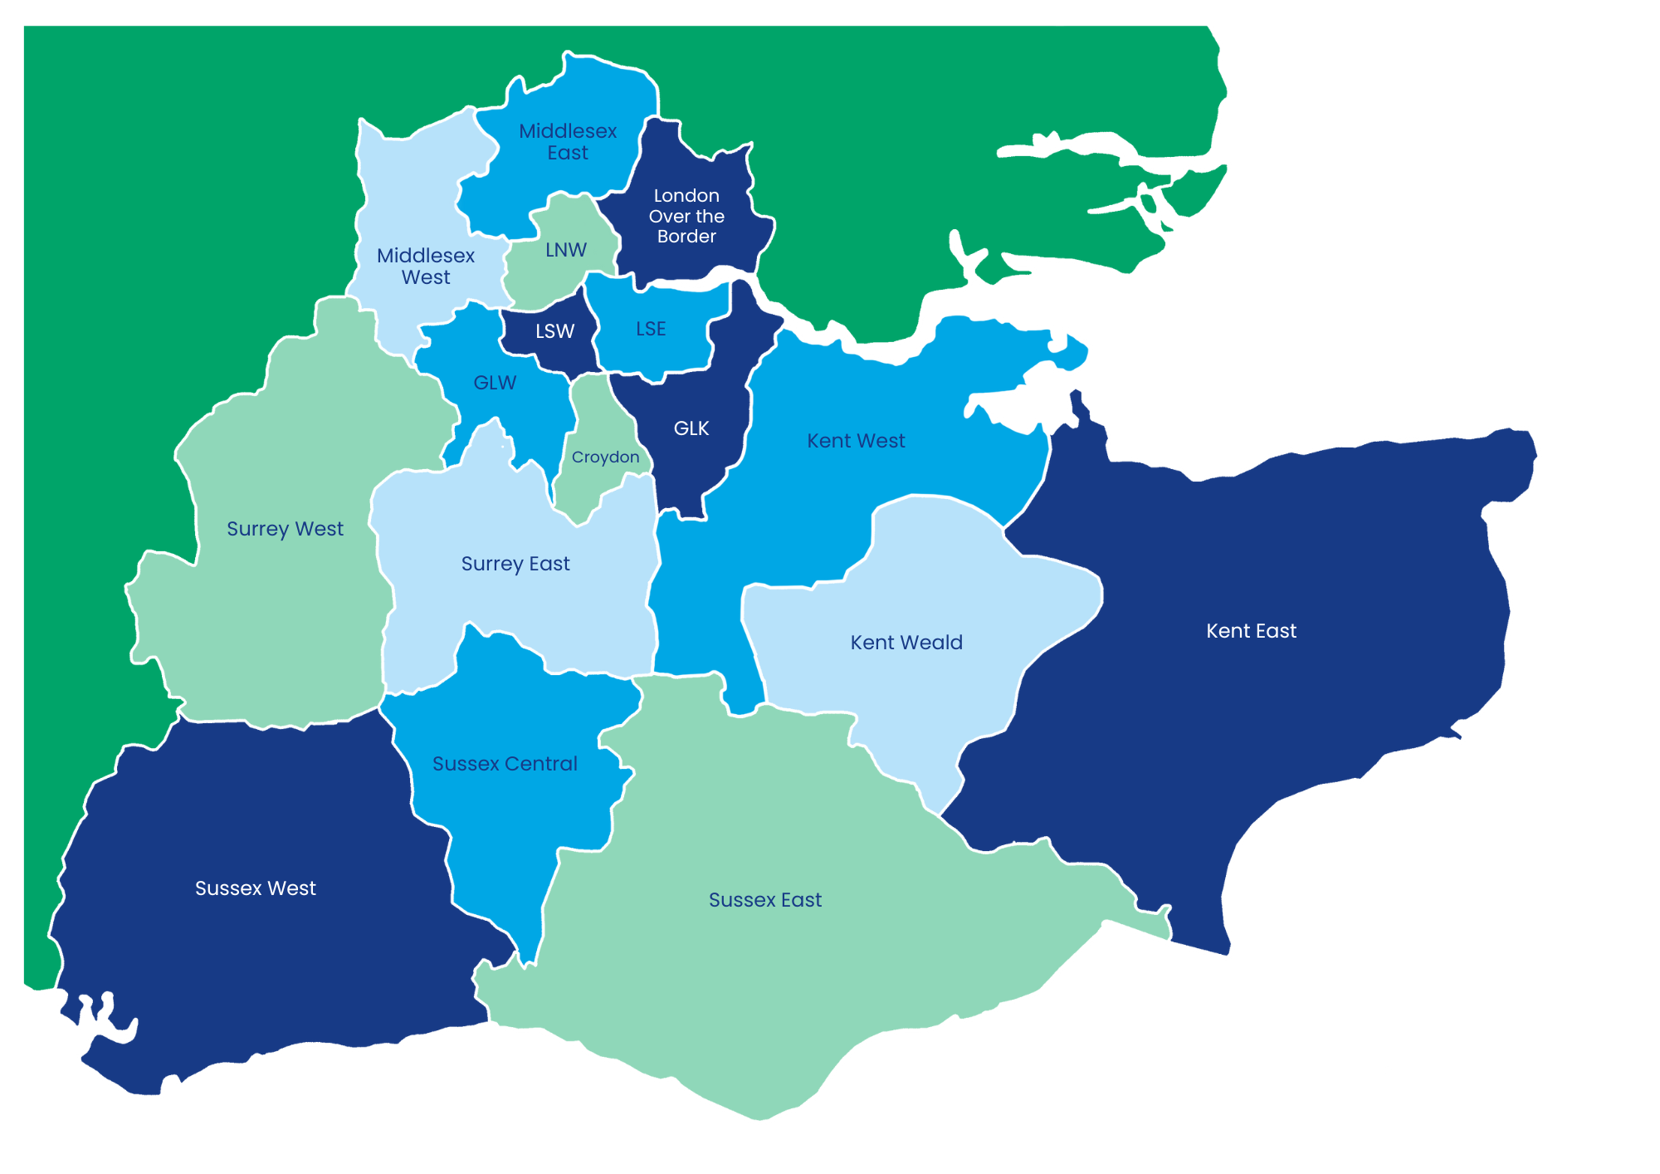

**Our structure**

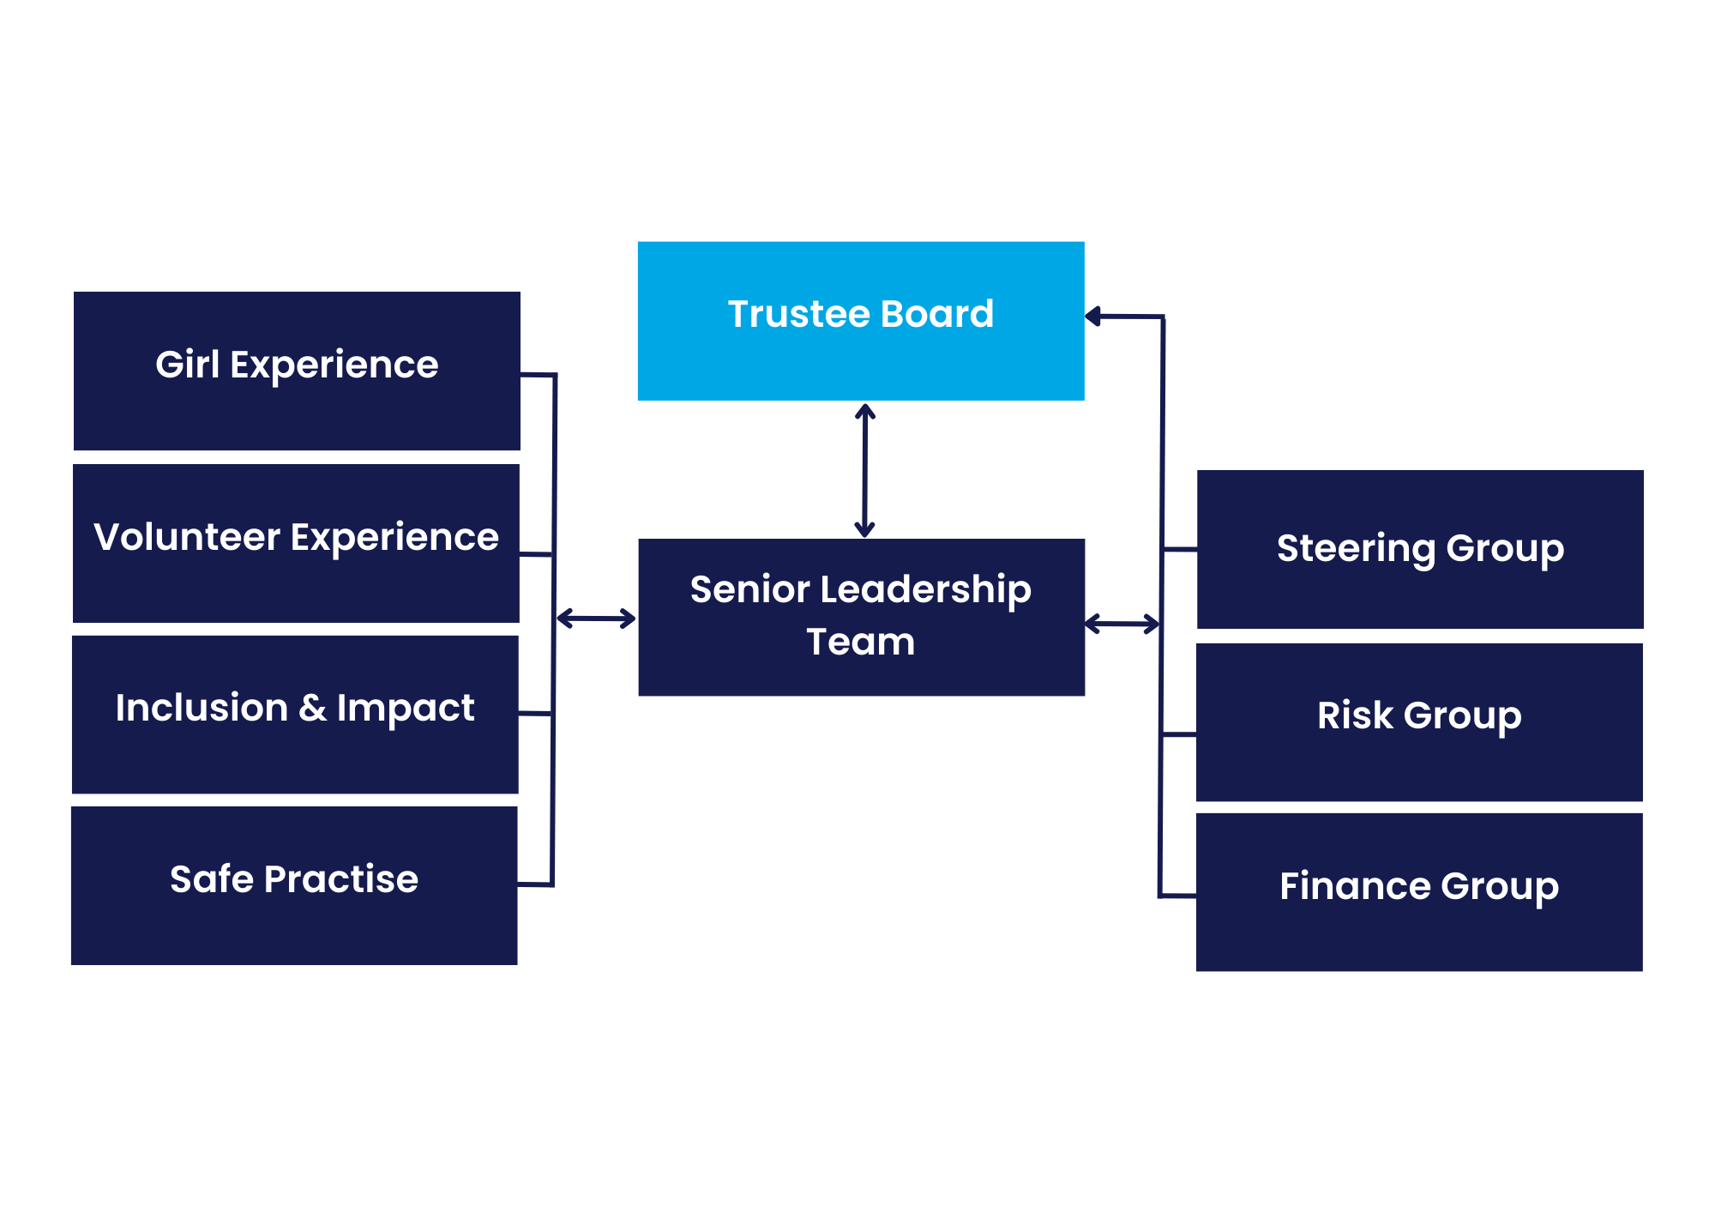

**About the board of trustees**

Composition of the Trustee Board: 10 – 13 Trustees.Membership to include:

* Chief Commissioner (Chair of Trustees, unless she appoints her deputy to take on this role)
* Deputy Chief Commissioner
* Trustee Treasurer
* Two County Commissioners
* 4 places from Girlguiding London and South East England membership who bring the skills required of the Trustee role, at least two of these from the 18 to 30 age group (at time of appointment)
* Two external appointments
* Region Manager attends

The additional two places may be used to ensure that there is an appropriate range of skills within the Trustee Board to deliver its purpose.

**Purpose and role of the Trustee Board**

The purpose and role of the Trustee board includes:

* To direct Girlguiding London and South East England Region
* To be Trustees of Girlguiding London and South East England
* To approve the Statement of Purpose and Strategic Plan
* To ensure all activities and events are within the strategic direction of the Region
* To ensure that vision and values of Girlguiding are operated in Girlguiding London and South East England
* To receive reports and feedback from the Steering, Risk and Finance Groups, and the Senior Leadership Team meetings
* To provide wide representation of Girlguiding London and South East England members
* To ensure financial viability of the organisation including long term financial strategy, and monitoring of income and expenditure
* To ensure effective communication between the Chief Commissioner, Trustee Board and other groups within the Girlguiding London and South East England structure
* To provide support and challenge to the Region Manager

**Responsibilities of Trustees**

The Girlguiding London and South East England Board of Trustees has overall legal responsibility for the direction, management and control of Girlguiding London and South East England, and is collectively accountable for compliance with relevant legislative and regulatory requirements. Girlguiding London and South East England ’s day- to-day operations are undertaken by Girlguiding London and South East England staff and volunteers under the overall leadership and supervision of the trustees.

Trustees have legal duties and responsibilities and make decisions collectively. Everyone has the responsibility to contribute to discussions and decisions. However, once that decision has been taken they have a further responsibility to uphold and support that decision. All matters discussed in closed sessions must be regarded as strictly confidential.

Being a trustee is a voluntary role, undertaken because you have a commitment to furthering the purposes of Girlguiding London and South East England and have the skills, experience and personal qualities needed for the strategic management of the organisation. All reasonable expenses will be reimbursed.

To serve as a trustee you must be over the age of 18 and not disqualified because of bankruptcy, unspent criminal convictions for offences of deception or dishonesty, or a legal order for removal/disqualification as a trustee or company director. It is a criminal offence to act as a trustee while disqualified.

For more information on becoming a trustee and what is involved, please see the [Charity Commission webpage](http://www.charitycommission.gov.uk/trustees-staff-and-volunteers/trustee-%20role/becoming-a-trustee/).  
  
**Person Specification**

Trustees will be expected to bring the following:

* A commitment to Girlguiding London and South East England and a proactive interest and enthusiasm in shaping and advising on the future of Girlguiding London and South East England.
* A willingness to devote the necessary time and effort to attend meetings (virtual and in person) including undertaking the appropriate preparation reading and work.
* Good independent judgement and the ability to give constructive challenge.
* An ability to think creatively and strategically.
* An understanding and acceptance of legal duties, responsibilities and liabilities of trusteeship and the roles of boards.
* An ability to work effectively as a member of a team.
* A commitment to Nolan’s seven principles of public life: selflessness, integrity, objectivity, accountability, openness, honesty and leadership.
* Strong communication skills and the ability to analyse and interpret information.
* Be at least 18 years of age.

**Skills needed within the Trustee Board**

Each person needs to demonstrate only *some* of these:

1. Audit and risk management

2. Strategic planning

3. Youth participation in practice

4. Finance and investment

5. IT

6. HR and recruitment

7. Strategic partnerships

8. Marketing, innovation & creative

9. Fundraising and income generation

10. Membership communications and PR

11. Social media & digital

12. Education policy and practice

13. Public policy development

14. Legal and safeguarding

15. Management and leadership of volunteers

16. Performance management/measuring impact

17. Business/commercial experience

18. Experience/capability

19. Chair a meeting/committee

20. Represent Girlguiding London and South East England externally

21. Represent Girlguiding London and South East England internally

22. Operational guiding leadership

23. Guiding membership experience

24. Guiding volunteering experience

25. Charity governance and management

26. Other governance experience

27. Understanding of the wider guiding family (including Trefoil Guild, WAGGGS, and SSAGO)

**Example of Annual Meeting Schedule**

|  |  |  |
| --- | --- | --- |
| **2025 Meeting Schedule** | | |
| Friday 7 - Sunday 9 February 2025 | Region Team Weekend | De Vere Hotel, East Horsley |
| Saturday 22 March | Trustee meeting | HQ, Wandsworth Common |
| Saturday 7 June | Trustee meeting | HQ, Wandsworth Common |
| Saturday 27 September | Trustee meeting | HQ, Wandsworth Common |
| Saturday 29 November | Trustee meeting | HQ, Wandsworth Common |

**How to apply**

Please complete the application form to include a personal statement outlining:

a) How you feel you fulfil the person specification outlined on page 6.  
b) Which of the skills from the list on page 7 you feel you bring  
c) Why you wish to be considered for a role on the Girlguiding London and South East England Board of Trustees.

Please give examples where you can of the skills and knowledge you have, these may have been gained either from inside guiding or from your work or other volunteer roles outside of guiding.

(Please note people employed by Girlguiding, Girlguiding London and South East England or any other Girlguiding entity cannot apply for a trustee position).

Please email your application (you only need to send pages 9 and 10 of this pack) in confidence to <trustee@girlguidinglaser.org.uk>.

Mark your email for the attention of: Amanda Teasel, Chief Commissioner and Chair of Trustees. Your application must be received by **midnight on Sunday 18 May 2025**.

Shortlisted applicants will be invited for an interview, which will be held virtually week beginning 19 May 2025. Please note your availability for interview on the application form.

**Membership Trustee Application Form**

|  |  |
| --- | --- |
| Full Name: |  |
| Preferred Name: |  |
| Membership No: |  |

|  |  |
| --- | --- |
| Contact Details: | |
| Home Telephone No: |  |
| Mobile: |  |
| Work No: |  |
| Email Address: |  |

|  |  |  |  |
| --- | --- | --- | --- |
| Current Girlguiding Role/s: | | | |
| Role | Unit / District | Division | County |
|  |  |  |  |
|  |  |  |  |
|  |  |  |  |
|  |  |  |  |
|  |  |  |  |

|  |  |  |  |
| --- | --- | --- | --- |
| Previous Girlguiding Role/s: | | | |
| Role | Unit / District | Division | County |
|  |  |  |  |
|  |  |  |  |
|  |  |  |  |
|  |  |  |  |
|  |  |  |  |

|  |
| --- |
| Please note your availability for virtual interview from 27th May to 25th June below: |
| Any other comments regarding availability or access needs you would like us to be aware of: |

**Trustee Personal Statement**

* Please provide a personal statement detailing the experience that you feel you could offer as a trustee for Girlguiding London and South East England
* How you feel you fulfil the person specification outlined on page 6
* Which of the skills listed on page 7 you feel you can offer, with brief examples of when you have used these skills
* Why you wish to be considered as a Girlguiding London and South East England Trustee
* Your personal statement should be no more than 1000 words

|  |
| --- |
|  |